
PROFESSIONAL DEVELOPMENT SCHOLARSHIP PROGRAM

Available 2025 Scholarships
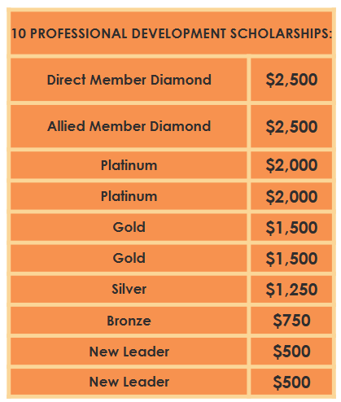

Total $15,000
Scholarship Selection Process:
- Scholarship Applications accepted until March 28, 2025 5 P.M. CDT
- Applications are masked by GBTA Texas VP of Direct Membership and shared as anonymous submissions to the scholarship committee of ten (10) members.
- Committee members will review and score scholarship applications based on completeness of the application, organization of the essay and clarity of personal and career goals.
- Diamond Award of $2,500 will be given to One (1) Allied Member and One (1) Direct Member
- Special consideration will be given to those applicants with less than 3 years of travel industry experience for qualification of “New Leader” Scholarships.
- Committee members will submit results to the Chair for review and final scoring.
- Results from the Chair are sent to GBTA Texas VP Direct, to share with the GBTA Texas board for review and approval.
- Scholarship winners will be announced at the April GBTA Texas virtual meeting and will receive an individual email with the Award announcement the day after the April GBTA Texas monthly meeting.

Please note that scholarship funds must be used by 12/31/2026

Good luck!
GBTA Texas Scholarship Committee Co-Chairs
Shantrice Rogers & Shurrie Potts



2025 Professional Scholarship Application Form

NAME: Click or tap here to enter text. | TITLE: Click or tap here to enter text.
COMPANY: Click or tap here to enter text. | PHONE: Click or tap here to enter text.
E-MAIL: Click or tap here to enter text.

1. Years in Travel Industry: Enter Years
2. Years GBTA Texas Chapter Member: Enter Years
3. Industry, GBTA, TED & GBTA Texas Events (Officer, Committees, Speaker, etc.) within the last 3 year

- Click or tap here to enter text. | - Click or tap here to enter text.
- Click or tap here to enter text. | - Click or tap here to enter text.
- Click or tap here to enter text. | - Click or tap here to enter text.

4. Accomplishments, Awards, Certifications and Publications within the last 3 years
- Click or tap here to enter text. | - Click or tap here to enter text.
- Click or tap here to enter text. | - Click or tap here to enter text.
- Click or tap here to enter text. | - Click or tap here to enter text.

5. Civic / Community Activities within the last 3 years
- Click or tap here to enter text. | - Click or tap here to enter text.
 | - Click or tap here to enter text.
- Click or tap here to enter text. | - Click or tap here to enter text.

6. Share ideas you have on how to give back or help improve GBTA Texas/GBTA or the travel industry?
- Click or tap here to enter text. | - Click or tap here to enter text.
- Click or tap here to enter text. | - Click or tap here to enter text.
- Click or tap here to enter text. | - Click or tap here to enter text.

7. Essay --The essay is necessary to provide information to understand the merits, accomplishments, and other reasons why the applicant should be selected for a 2025 Professional Development Scholarship. The essay should describe your experience, professional and personal accomplishments and career goals and objectives. In addition to these elements, the essay will be scored on organization, clarity, and persuasiveness. The essay should be 250-1000 words and should not include positions held, company names or any other personal or professional identifiable information.
ENTER ESSAY HERE

APPLICANT ENDORSEMENT: I acknowledge that I am applying for a 2025 Professional Development Scholarship. I understand that should I be awarded a scholarship in 2025, it would only be applicable for registration and approved T&E charges associated directly with Travel Industry Professional Development opportunities.
In addition, I understand that I must be an active GBTA Texas member at the time of reimbursement, my membership may not have lapsed and that receipts must be provided to GBTA Texas for any items that are to be reimbursed associated with professional development events or classes.

Some activities that are pre-approved by the 2025 GBTA Texas Board are as followed:
- GBTA continuing education programs (including Legislative Symposium, GTP, GLP, Master’s Program)
- Global Congress on Risk Management
- GBTA Texas Membership
- GBTA Texas Education Day
- GBTA Membership
- GBTA Convention registration and attendance (including Airfare, Hotel room and tax and airport parking)
- Professional development websites (i.e.: LinkedIn)
- Continuing education at an accredited College or University in a field that benefits a travel industry career goal.

My company leadership has been made aware of my intent to request this scholarship and has indicated that they will support any event attendance should I receive the scholarship, and acknowledge scholarships are non-transferable.
If I am awarded a Diamond, Platinum, Gold, Silver, Bronze or New Leader level scholarship, I agree to serve on the Scholarship Committee for a minimum of one year and I understand that while I serve on the scholarship committee, I will not be eligible to apply for any GBTA Texas Chapter scholarships. As the scholarship funds are valid until December 31, 2026, I will also not be eligible to apply for GBTA Texas Professional Development Scholarships until 2027. Should I be unable to use all the professional development funds by December 31, 2026, I agree to provide GBTA Texas written notification, so the funds can be returned to the GBTA Texas budget for the following year’s Professional Development Scholarship program.

_________________________________________ Click or tap to enter a date.
Signature (electronic is accepted) Date

Please submit completed applications to: Adam Turetsky, VP of Direct Membership @ scholarships@texasbta.org

Deadline for submission is: 5:00pm on Friday, March 28, 2025

